***Hackathon DAY 4***

***Introduction:***

My website is a rental e-commerce platform designed for people who cannot afford expensive furniture. It allows students, employees, and anyone in need of furniture for their hostel rooms or homes to rent affordable and various types of furniture. The platform offers a wide range of options at very reasonable prices.

***Steps taken to build and integrate components:***

***Home Page***

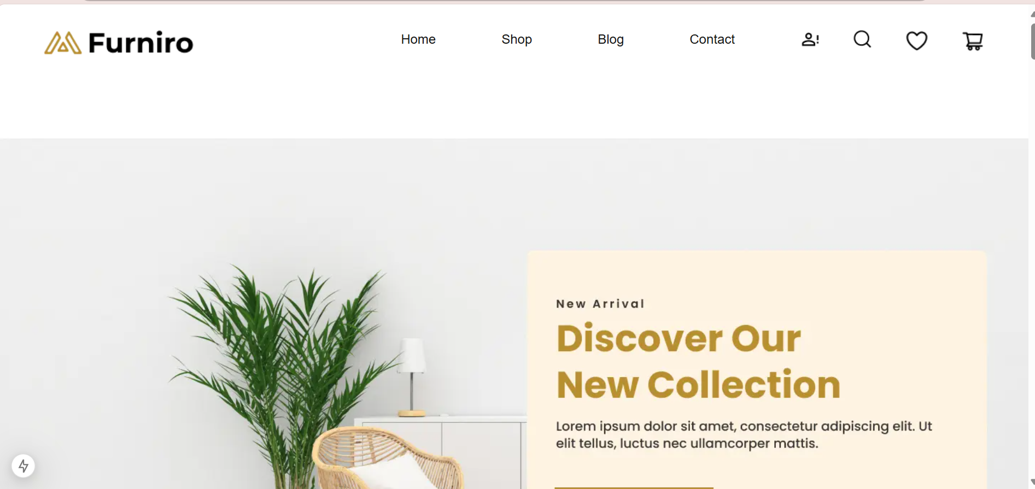

***Products from API***

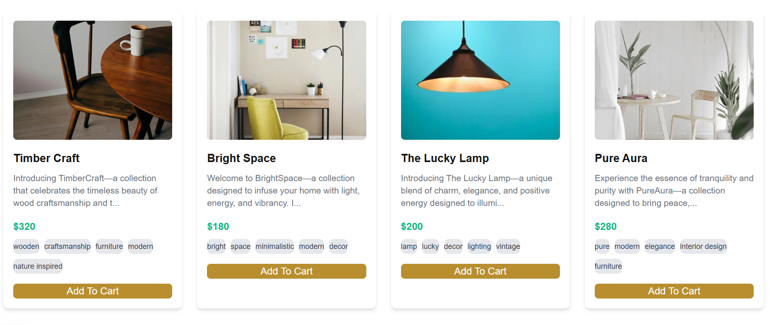

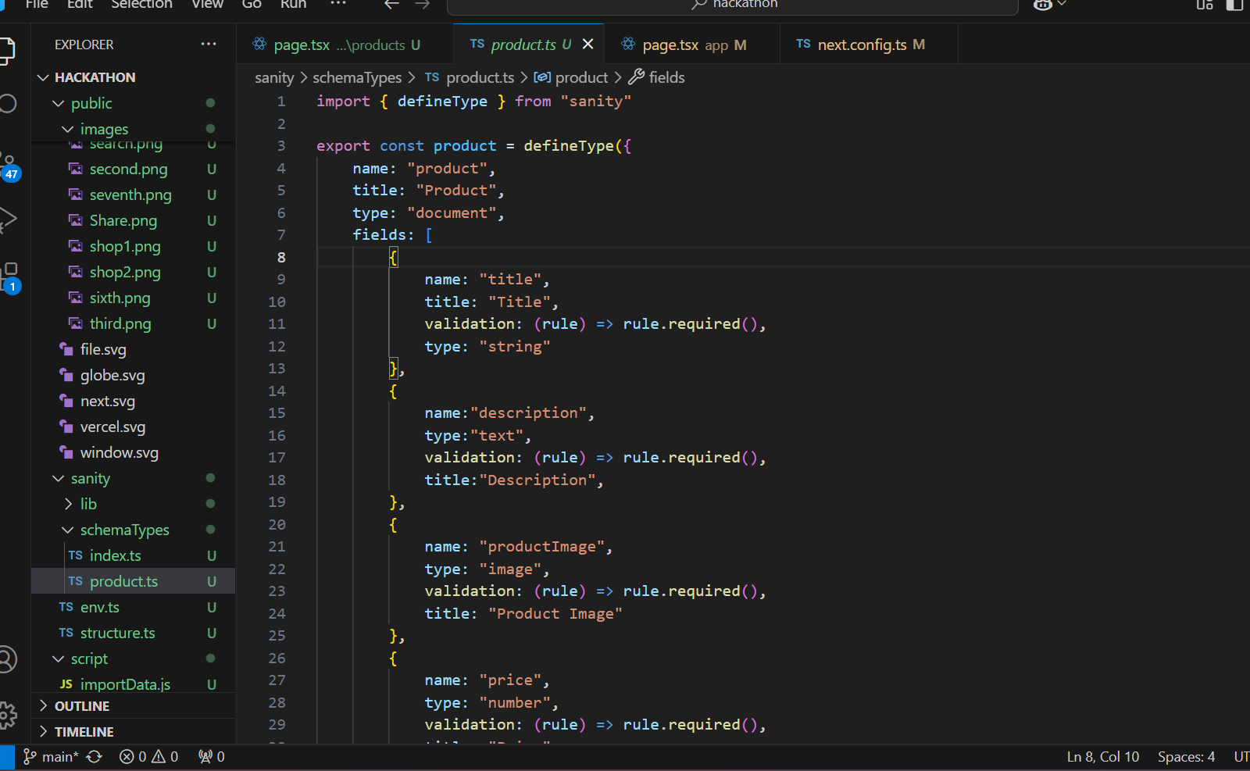

***Contact page***

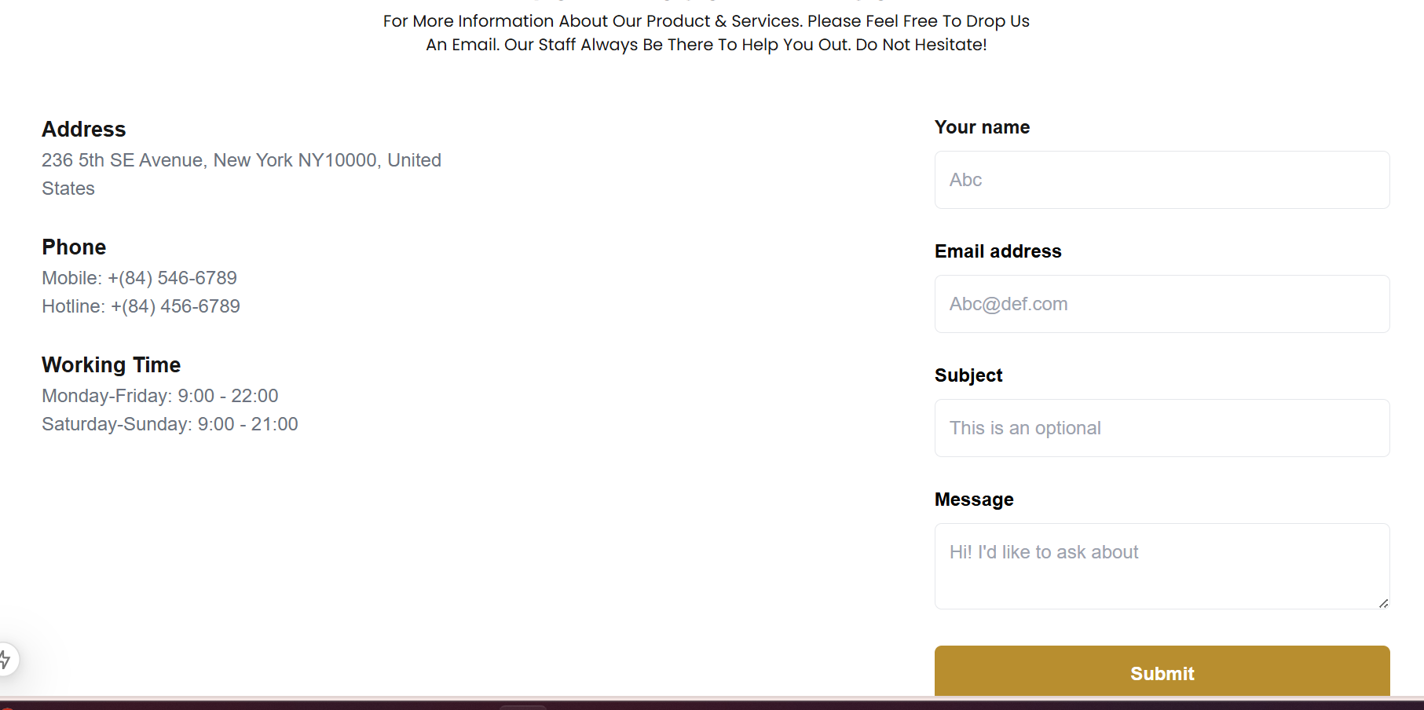

***Shop Page***

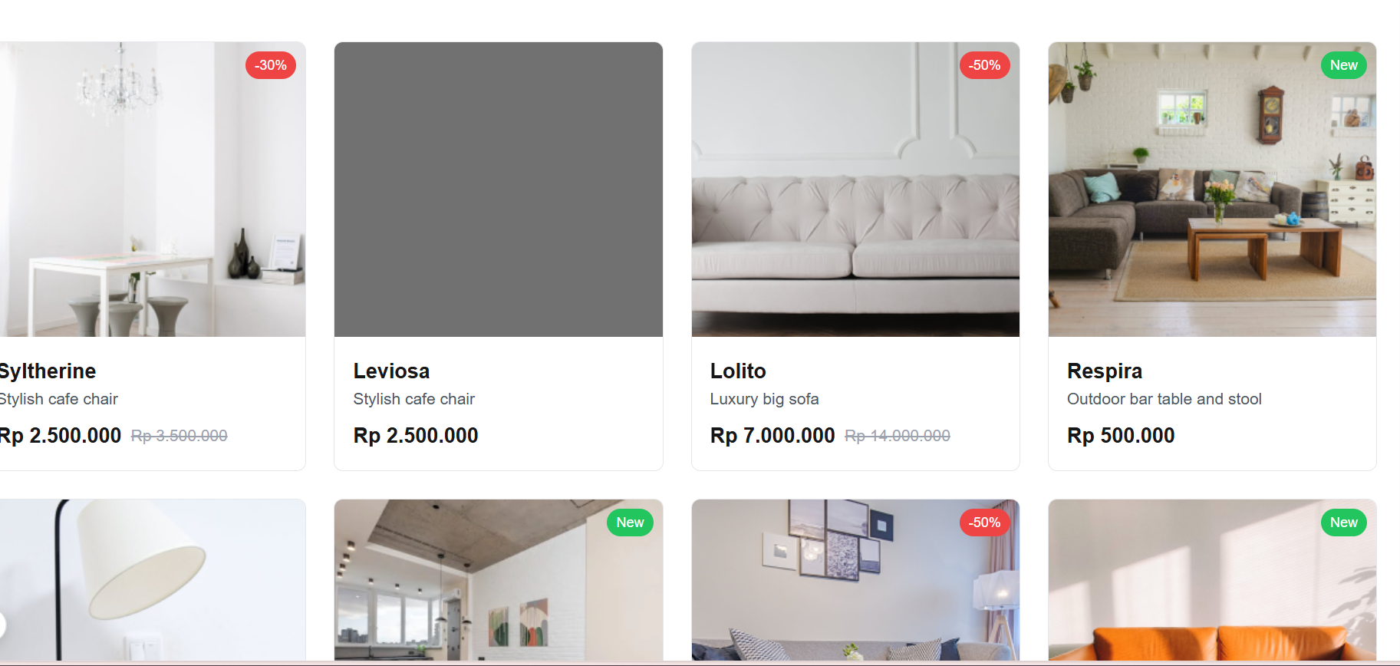

***Tags:***

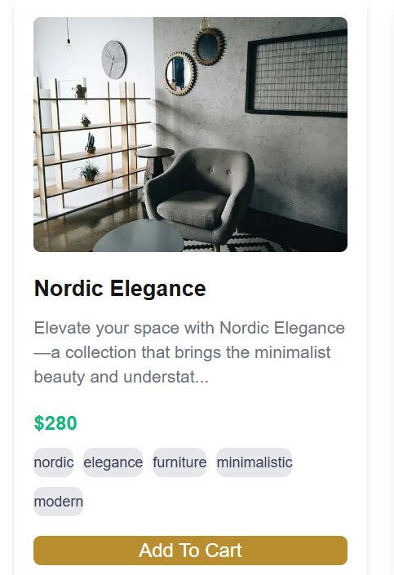

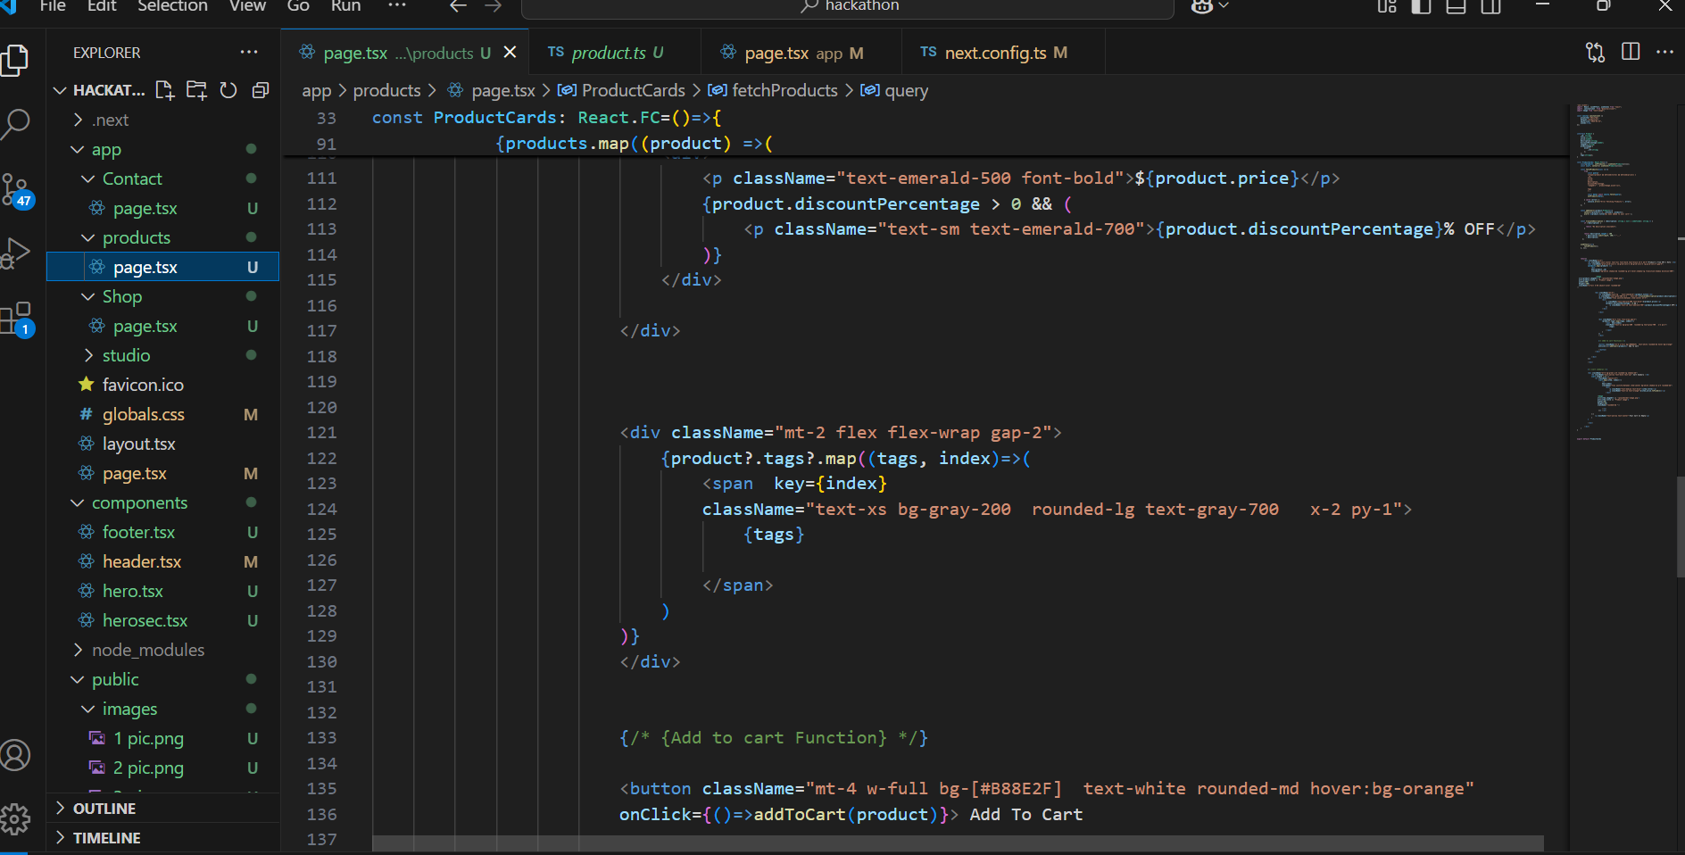

***Shop***

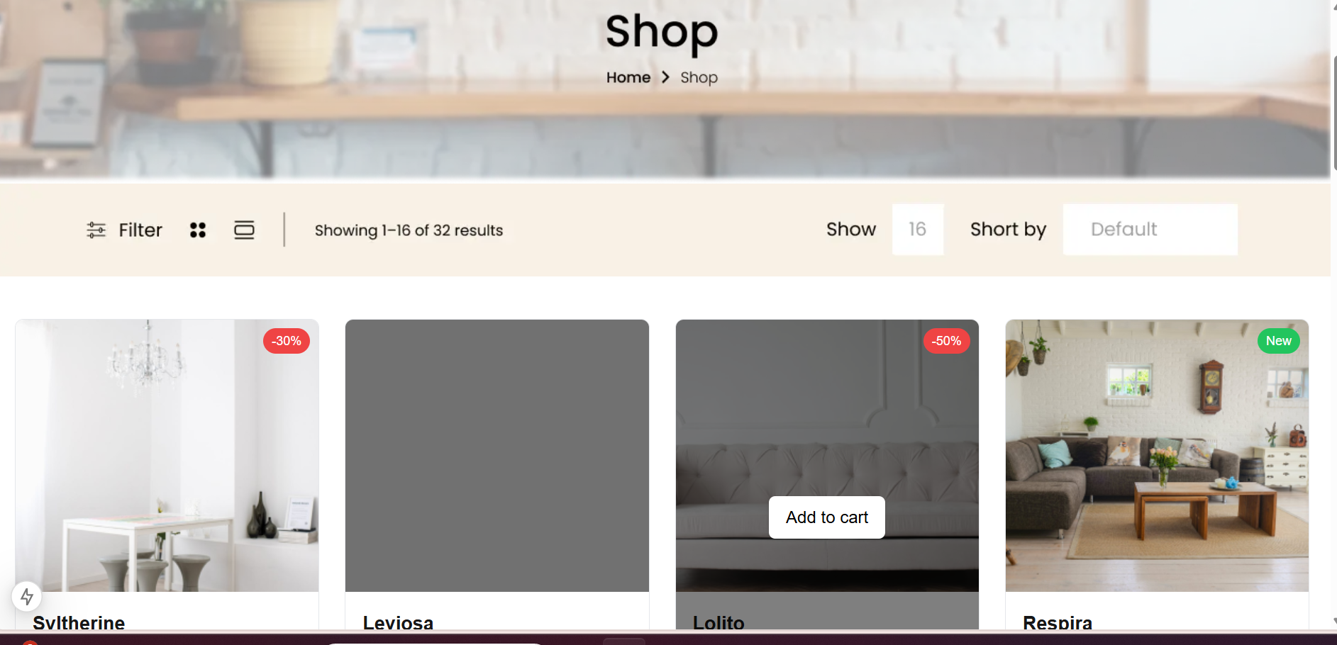

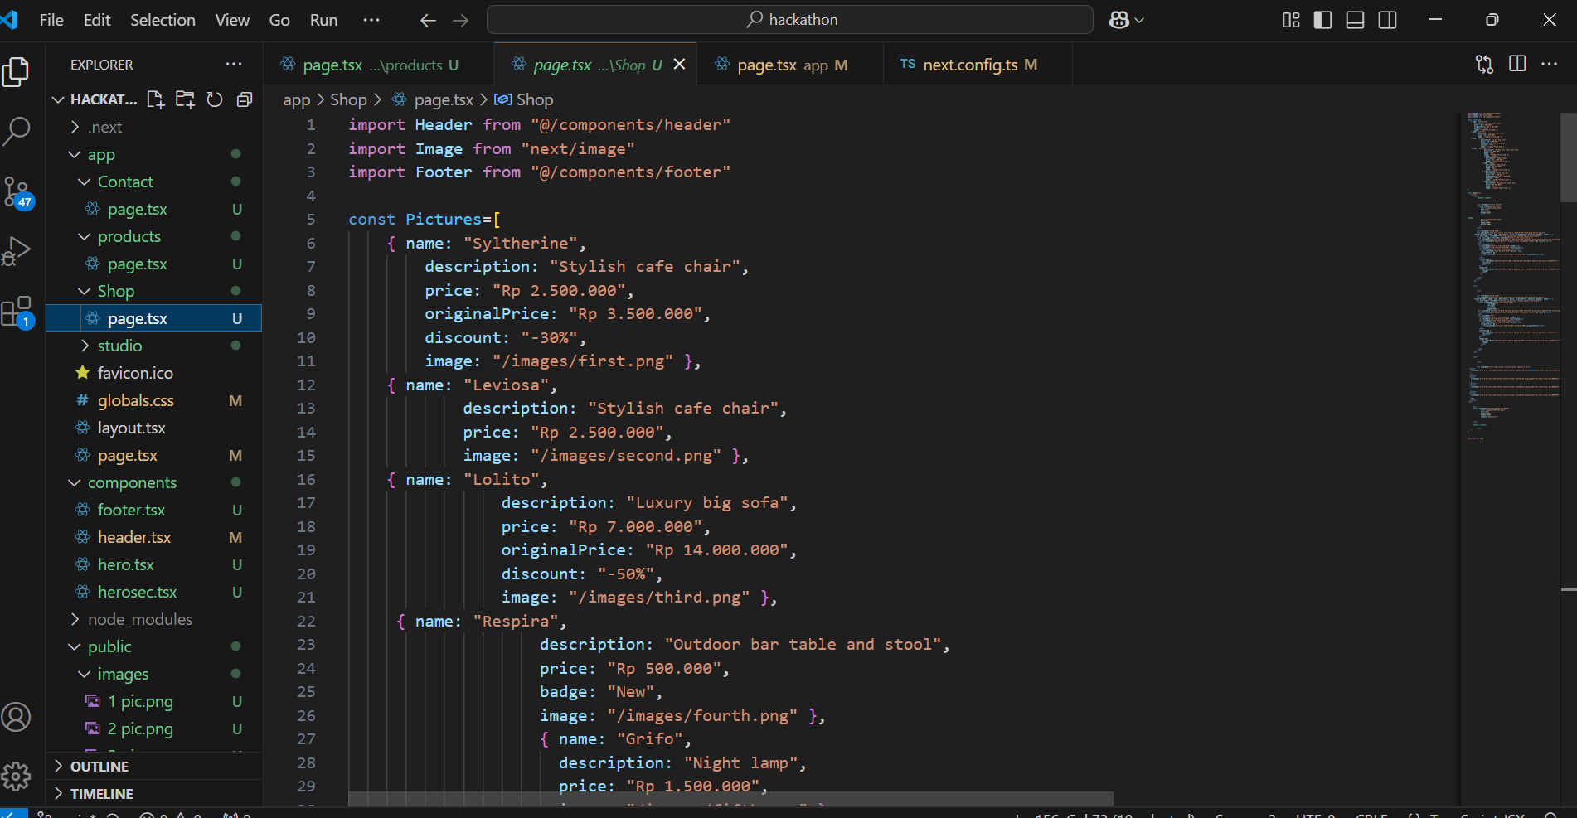

***Contact***

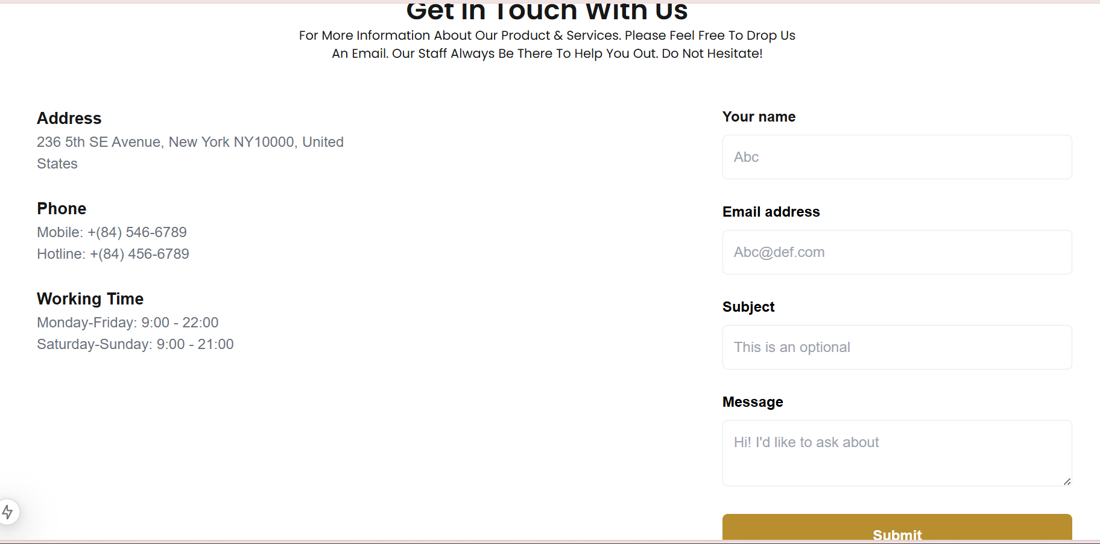

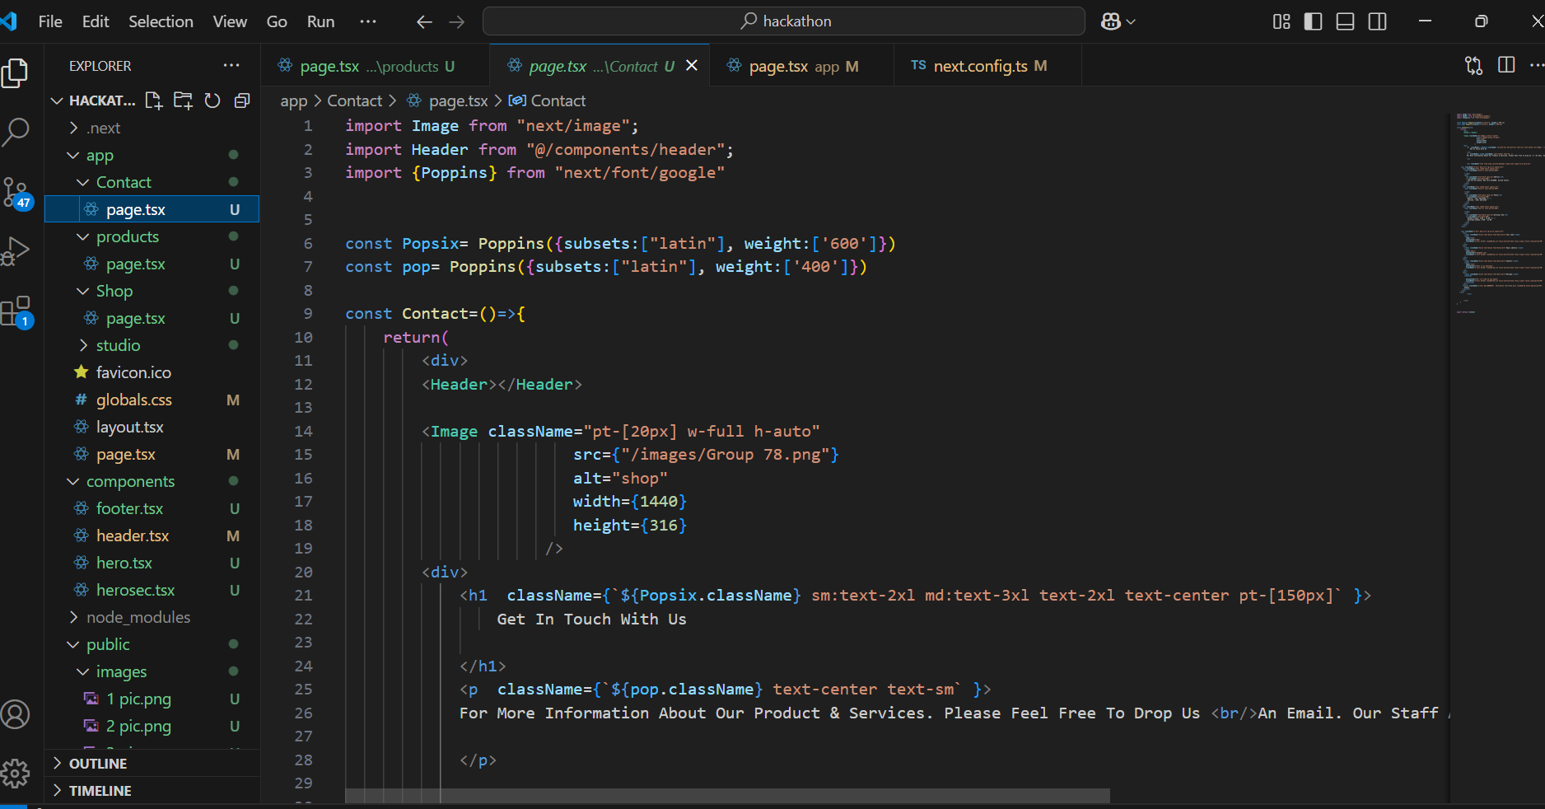

***Notification***

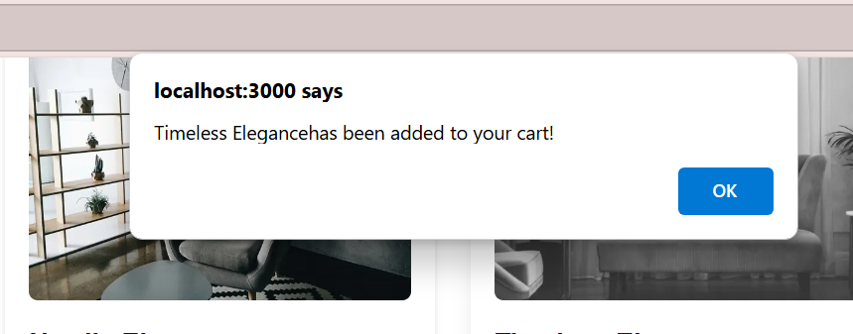

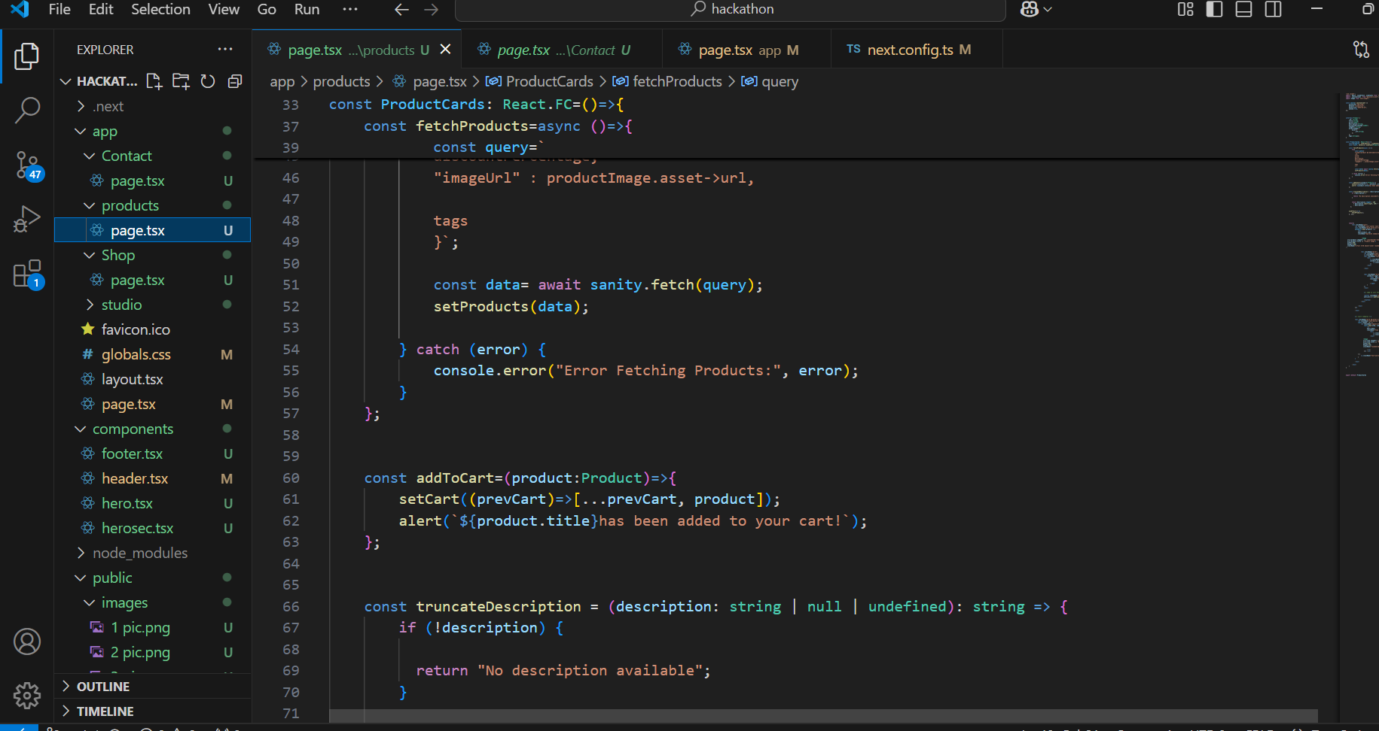

***Dynamic Routing***

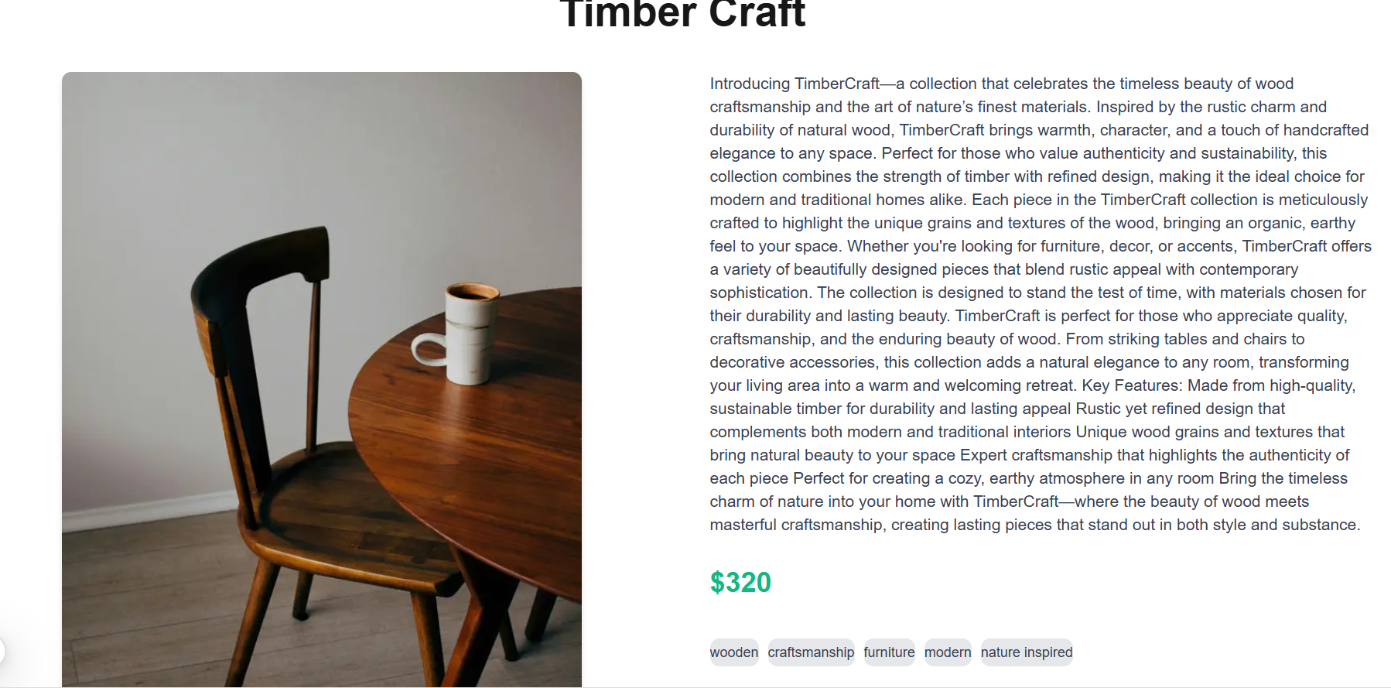

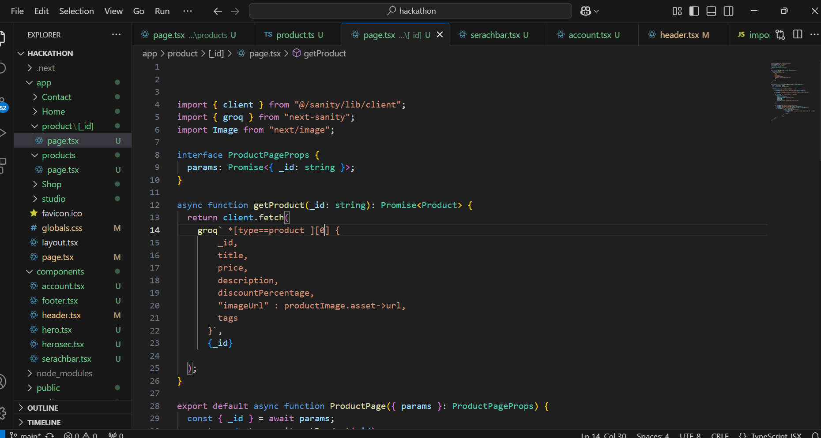

***Steps for Implementation:***

1. All the products from sanity and next.js is working properly.
2. All the styling is done through tailwind.CSS
3. The project has use useEffect and useState globally.

**Key components:**

**1.Searchbar:**

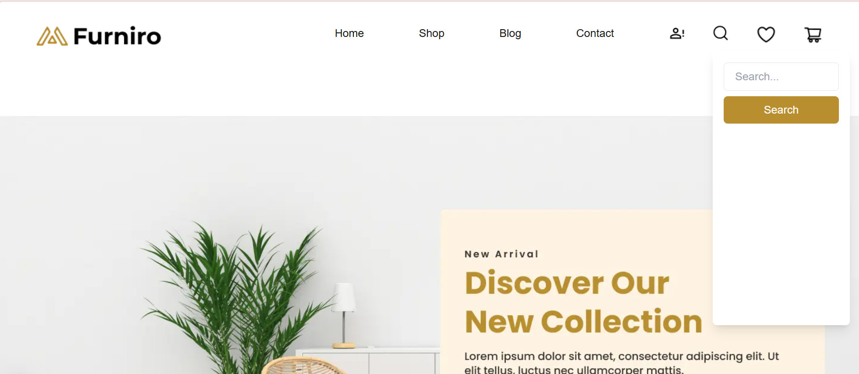

***2. Account signup/login***

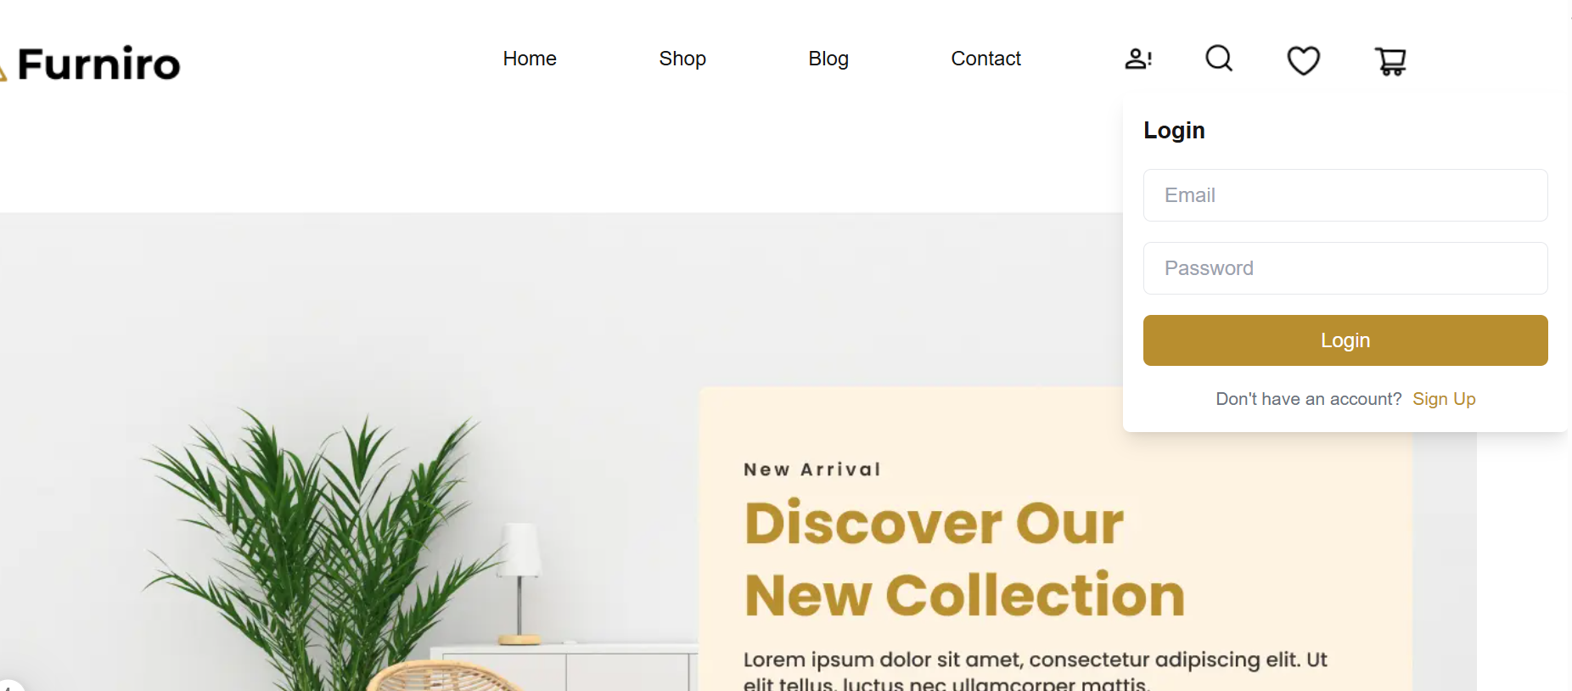

***Payment gateway integration:***

The payment method for the website is through Jazzcash and easypaisa. Or it can be done through cash on delivery for your easiness.

***Component Integration:***

The website has the cart, search and login or signup components integration.

***Conclusion:***

Our website is user-friendly because it has an easy-to-navigate interface, allowing customers to quickly find and rent the furniture they need. In the future, it will benefit users by providing an affordable and convenient way to access high-quality furniture without the burden of high upfront costs, making it ideal for students, employees, and anyone on a budget.